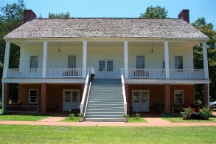
2nd Annual Fort Fest
Vendor Form/Application
June 2, 2018 10am - until

Name:
Address:
City: State: Zip:
Email:
Phone: Alternate Phone:
PLEASE NOTE: ALL VENDORS WILL BE OUTDOORS AT THE NAZERENE CAMP GROUNDS – NO ELECTRIC PROVIDED TO VENDORS. VENDORS ARE RESPONSIBLE FOR BRINGING ANY ITEMS NEEDED I.E. TENT, TABLES, CHAIRS, GENERATOR, ETC.
CLASSIFICATION:
Please describe type of merchandise:
AMOUNT DUE:
NON FOOD VENDOR $25 FOOD VENDOR $35
Checks should be made payable to FRIENDS OF FORT JESUP
Mail to: Teresa Miller
73 Clower Loop
Robeline, La. 71469

*I AGREE TO HOLD HARMLESS FRIENDS OF FORT JESUP, FORT JESUP STATE PARK, AND THE NAZARENE CAMPGROUND. I FURTHER UNDERSTAND THAT NEITHER OF THESE GROUPS ARE RESPONSIBLE FOR ANY LOST, DAMAGED, OR STOLEN ITEMS. I ALSO HOLD THEM HARMLESS FROM ANY TYPE OF LIABILITY – PERSONAL, PRODUCT, OR OTHERWISE. I AGREE TO SET UP AND OPERATE AT MY OWN RISK.
SIGNATURE_________________________________________________ DATE _____________________

